**Sql queries on pizza sales analysis**

**Solutions of different problem statement**

1. TOTAL REVENUE :

SELECT SUM(total_price) As total_revenue FROM pizza_sales;

Capture.PNG

1. AVERAGE ORDER VALUE :

select sum(total_price) / count(distinct order_id) as average_order_value from pizza_sales;



1. TOTAL QUANTITY SOLD :

Select sum(quantity) as total_quantity_sold from pizza_sales;

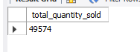

1. TOTAL ORDER :

select count(distinct order_id) as total_orders from pizza_sales;

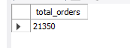

1. AVERAGE PIZZA PER ORDER :

select sum(quantity) / count(distinct order_id) as average_pizza_per_order from pizza_sales;



**THERE WAS A ERROR WHILE PERFORMING THE DATE QUERY**

* Data is in wrong format as ‘1-12-2005’ but MySql support ‘2005-12-01’ for conversion
* For conversion first need to disable the safe mode for mass manipulation on the data set

* For disable safe mode , the query
* SET SQL_SAFE_UPDATES = 0;
* Updated the data by the help of query
* UPDATE pizza_sales

SET order_date = STR_TO_DATE(order_date, '%d-%m-%Y')

WHERE STR_TO_DATE(order_date, '%d-%m-%Y') IS NOT NULL

AND pizza_ id IS NOT NULL;

* For re-enabling safe mode , the query (for maintain safety around data mass manupulation )
* SET SQL_SAFE_UPDATES = 1;

1. DAILY TREND OF TOTAL ORDERS :

select dayname(order_date) as order_day , count(distinct order_id) as total_orders from pizza_sales

group by dayname( order_date);

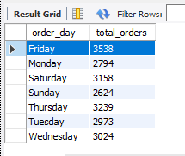

1. MONTHLY TREND FOR TOTAL ORDERS :

SELECT monthname(order_date) as order_month , count(distinct order_id) as toatal_orders from pizza_sales

group by monthname(order_date);

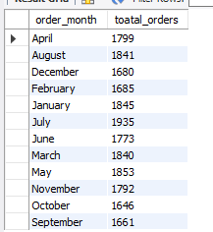

1. PERCENTAGE OF SALES BY PIZZA CATEGORY :

select pizza_category , sum(total_price)*100 / (select sum(total_price) from pizza_sales) as percentage from pizza_sales

group by pizza_category;

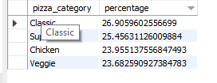

1. TOTAL PIZZA SOLD BY PIZZA CATEGORY :

(“CAST (query ... as decimal (10,2)) ” use to limit values after decimal )

select pizza_size, cast( sum(total_price)*100 / (select sum(total_price) from pizza_sales) as decimal(10,2)) as percentage from pizza_sales

group by pizza_size;

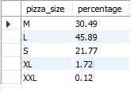

* (For total quantity result , [replace total_revenue with total_quantity ] in the below given queries)
* (For total orders [sum(total_price) as total_revenue] replace this with [count (distinct order_id )as total_orders order by total_orders] )

1. TOP 5 BEST SELLERS BY REVENUE , TOTAL QUANTITY AND TOTAL ODERS :

(by default ‘order by’ returns ascending values )

select pizza_name , sum(total_price) as total_revenue from pizza_sales

group by pizza_name

order by total_revenue

limit 5 ;

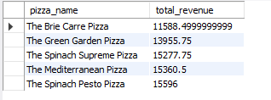

1. BOTTOM 5 BEST SELLERS BY REVENUE , TOTAL QUANTITY AND TOTAL ODERS :

select pizza_name , sum(total_price) as total_revenue from pizza_sales

group by pizza_name

order by total_revenue desc

limit 5 ;

